<COVID 19 ANALYSIS>
Submitted for

DATA VISULIZATION AND DASHBOARD

Submitted by:
( E23MCAG0008 ) YADNESH SINGH
( E23MCAG0041 ) UDAY RAJ SINGH
( E23MCAG0075 ) UPDESH SINGH

Submitted to-
Dr. Nitin Arvind Shelke

July-Dec 2023
SCHOOL OF COMPUTER SCIENCE AND ENGINEERING


INDEX

Sr No
Content | Page No
1. | Introduction | 3
2. | Aim of project | 4
3. | Insights and information | 5
4. | Complications and troubles | 16
5. | Measures | 17
6. | Conclusion | 18

LIST OF FIGURES

Figure No. | Title | Page No.
2.1 | Block diagram | 12
2.2 | Stack Bar chart | 6
2.3 | 3d Bar Chart | 8
2.4 | Pie Chart | 7
2.5 | 3d pie Chart | 9
2.6 | Simple Bar Chart | 10
2.7 | Scatter Plot | 11
2.8 | Line Plot | 12
2.9 | 3d Clustered Column Chart | 13
2.10 | Clustered Column Chart | 14
2.11 | Map | 15

- ABSTRACT
This project seeks to offer comprehensive insights into the multifaceted impact of the COVID-19 pandemic on diverse facets of daily life. Leveraging data analysis techniques, our study aims to discern patterns and trends associated with global COVID-19 cases, deaths, and recoveries, as well as their localized variations in specific regions or countries. Utilizing advanced data visualization tools, we intend to enhance the communicative effectiveness of our findings, facilitating a nuanced understanding of the pandemic's dynamics. Through this research, we aspire to contribute valuable knowledge that can inform public health strategies, policymaking, and community responses to better navigate and mitigate the effects of the ongoing global health crisis.

- INTRODUCTION AND RELATED WORK
In this chapter give introductory information about your work and formulate the Coronaviruses are a large family of viruses that are known to cause illnesses ranging from the common cold to more severe diseases such as Middle East Respiratory Syndrome (MERS) and Severe Acute Respiratory Syndrome (SARS). A novel coronavirus (COVID-19) was identified in 2019 in Wuhan, China. This is a new coronavirus that has not been previously identified in humans.
.
- SOFTWARE USED
Jupyter Notebook , Power BI , Excel , Google Colab

- METHODOLOGY --- Flowchart is compulsory.
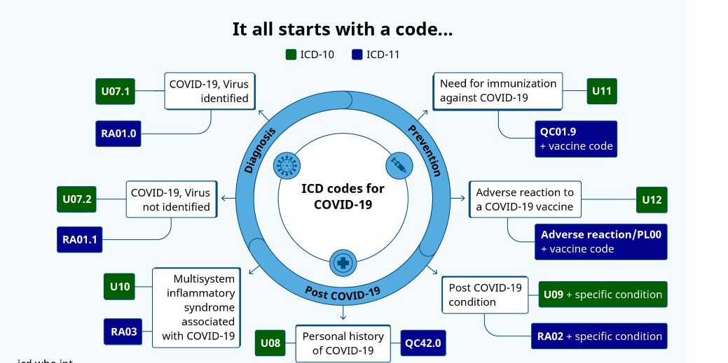
- EXPERIMENTAL RESULTS
More and more testing should be our priority whenever this kind of unknown pandemic erupts. Places with high population density should have strict rules to avoid further spread. To prevent the spread of COVID-19, it is essential to take preventive measures such as getting vaccinated, wearing a mask, washing hands frequently, practicing physical distancing, and avoiding large gatherings.

- CONCLUSION
COVID-19 is a highly contagious respiratory illness caused by the SARS-CoV-2 virus. It has caused a global pandemic with significant social and economic impacts. States or UTs with high population density were mostly affected more and States or UTs with less migration or isolated from big cities or states were less affected. The virus spreads primarily through respiratory droplets when an infected person talks, coughs, or sneezes. The symptoms of COVID-19 can range from mild to severe and can include fever, cough, fatigue, and loss of taste or smell. Vaccines are highly effective in preventing severe illness, hospitalization, and death from COVID-19, and everyone eligible should get vaccinated as soon as possible

- REFERENCES

Minimum 5 reference is required (You may use the research article)

Typesetting:
- Font: Times new roman
- Font size for the text: 12, Font size for Chapter name: 16 (Bold)
- All material should be typed in 1.5 line spacing using times new roman and the vertical space between paragraphs shall be 2.5 line spacing.
- The recommended margins are 25 mm (1 inch) for top, bottom, right and left with an extra 13 mm (0.5 inch) for binding on the left. Other than page numbers, no material should intrude into these margins.

Note: Plagiarism should not be more than 20%

